Curricula: Trainer Account Creation
Step 7: Defect Reporting
Document ID: QA-CURRICULA-TRAINER-STEP7
Defect Reports, End to End QA Workflow, prior to production release

Contents
1. Purpose 5
2. Severity Classification 5
3. Defect Summary 5
4. BUG-01: ID Number accepts any value with no format or checksum validation 6
5. BUG-02: No duplicate check exists for Primary email or ID Number 8
6. BUG-03: Identification Document upload is always mandatory, contradicting its own on-screen hint 11
7. BUG-04: Trainer ID is generated randomly, not sequentially, and is not checked for uniqueness 13
8. BUG-05: ID Type dropdown does not match the FSD's documented enumeration 16
9. BUG-06: Emergency contact relationship dropdown does not match the FSD's documented enumeration 18
10. BUG-07: Block/Building Number and Unit Number are capped at 9 characters, one short of the FSD's stated 10 20
11. BUG-08: Primary contact number under +65 rejects valid 8-15 digit values outside an undocumented exactly-8 rule 21
12. BUG-09: Floor Number rejects letter-containing values not restricted by the FSD 23
13. BUG-10: Preferred Name and Emergency Contact Name accept up to 255 characters instead of the FSD’s stated 100 25
14. BUG-11: Country/Region dropdown still allows Singapore to be selected in Non-Singapore mode 27
References 32

List of tables
Table 1. Defect severity classification 5
Table 2. All defects raised in this cycle 6

List of figures
Figure 1. BUG-01 evidence 15
Figure 2. BUG-02 evidence 17
Figure 3. BUG-02 evidence 18
Figure 4. BUG-03 evidence 20
Figure 5. BUG-04 evidence 22
Figure 6. BUG-04 evidence 23
Figure 7. BUG-05 evidence 25
Figure 8. BUG-06 evidence 27
Figure 9. BUG-07 evidence 28
Figure 10. BUG-08 evidence 30
Figure 11. BUG-09 evidence 32
Figure 12. BUG-10 evidence 34
Figure 13. BUG-11 evidence 36
Figure 14. BUG-11 evidence 37
Figure 15. BUG-12 evidence 39

1. Purpose
This document records the defects identified during the Test Execution step (Step 6), by comparing the actual behavior of curricula_trainer_account.html against the Functional Specification Document. Step 6 was updated to execute the full 186-case test suite (TS-01 through TS-09); the "Related test case(s)" reference below have been updated to that suite's TC-TSxx-xxx-nnn identifiers. Where a defect has no directly corresponding case in the current 186-case suite, that gap is noted and a new case is recommended.

2. Severity Classification
Severity follows the classification established in the Test Plan (Step 3, Section 2.5.1).
Severity | Definition
Must Do | Must be worked on before anything else.
Blocker | The product does not function; work stops until it is resolved.
Critical | Major functionality problems that need immediate attention.
Major | Needs attention; partial functionality is affected.
Normal | Causing some functionality problems.
Minor | Minor functionality problems with a possible workaround.
Trivial | Cosmetic only, such as misspelt words or misaligned text.
Table 1. Defect severity classification
Priority follows the High/Medium/Low scale defined in the Requirement Analysis Findings report (Step 2, Table 1: Priority definitions). Findings F19 through F24 are new findings surfaced during Test Execution (Step 6) from curricula_trainer_account.html rather than during the original Requirement Analysis step; they are assigned a priority using that same scale rather than a separate one.

3. Defect Summary
ID | Severity | Priority | Title | Finding
BUG-01 | High | High | ID Number accepts any value with no format or checksum validation | F20
BUG-02 | High | High | No duplicate check exists for Primary email or ID Number | F21
BUG-03 | High | High | Identification Document upload is always mandatory, contradicting its own on-screen hint | F23
BUG-04 | Medium | Medium | Trainer ID is generated randomly, not sequentially, and is not checked for uniqueness | F24
BUG-05 | Medium | Medium | ID Type dropdown does not match the FSD's documented enumeration | F19
BUG-06 | Medium | Medium | Emergency contact relationship dropdown does not match the FSD's documented enumeration | F25
BUG-07 | Medium | Medium | Block/Building Number and Unit Number are capped at 9 characters, one short of the FSD's stated 10 | F26
BUG-08 | Low | Medium | Primary contact number under +65 rejects valid 8-15 digit values outside an undocumented exactly-8 rule | F27
BUG-09 | Medium | Medium | Floor Number rejects letter-containing values not restricted by the FSD | F28
BUG-10 | Medium | Medium | Preferred Name and Emergency Contact Name accept up to 255 characters instead of the FSD’s stated 100 | Step 6
BUG-11 | Low | Low | Country/Region dropdown still allows Singapore to be selected in Non-Singapore mode | Step 6
BUG-12 | Low | Low | Non-Singapore Postal Code has no length restriction (FSD: String/20) | Step 6
Table 2. All defects raised in this cycle

4. BUG-01: ID Number accepts any value with no format or checksum validation
Severity: Critical Priority: High
Related test case(s): TC-TS01-IDN-001 to 004 (closest coverage: valid / blank / spaces / duplicate). No case in the current 186-case suite enters a non-numeric or symbol value (e.g. "abc123!!") -- this defect was found by code inspection while executing TS-01-IDN. Recommend adding a dedicated invalid-format case.
Related requirement finding: F20
Steps to reproduce: 1. Open Create Trainer. 2. Fill every mandatory field with valid data. 3. Enter ID Number = “abc123!!” (or any arbitrary string). 4. Click Save.
Expected result: Save is blocked, since FSD Section 4 states a checksum algorithm validates the ID Number.
Actual result: Save succeeds. The only validation applied to ID Number in the real build is a non-empty check (requiredText), with no format, length, or checksum rule of any kind.
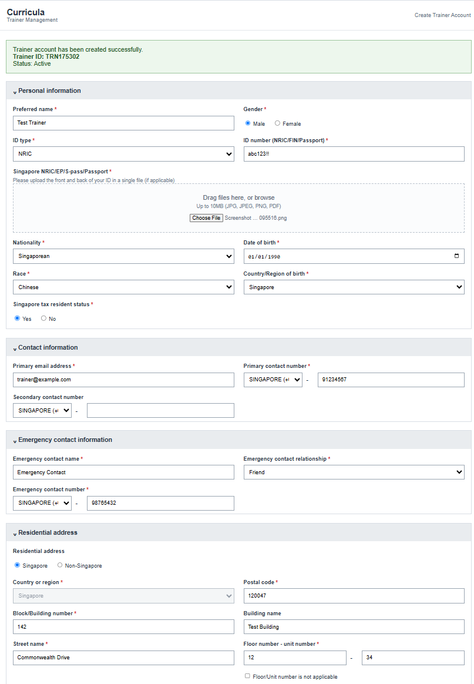
Figure 1. BUG-01 evidence

5. BUG-02: No duplicate check exists for Primary email or ID Number
Severity: Critical Priority: High
Related test case(s): TC-TS01-IDN-004, TC-TS02-EMAIL-006, TC-TS02-EMAIL-007, TC-TS06-DUP-001 to 004 (all recorded as Blocked in Step 6 -- the build has no persistence layer to create the "existing trainer" precondition -- but this defect is confirmed independently by code inspection of the Save handler, per Step 6 Section 2)
Related requirement finding: F21
Steps to reproduce: 1. Create and save one trainer account with a specific Primary email and ID Number. 2. Immediately create a second trainer account using the identical Primary email and ID Number. 3. Click Save.
Expected result: The second save is blocked with a duplicate-value error, per FSD Section 5.3 (“An account with this email address already exists.” / “An account with this ID number already exists.”).
Actual result: Both accounts save successfully. There is no comparison against previously created records anywhere in the Save handler.
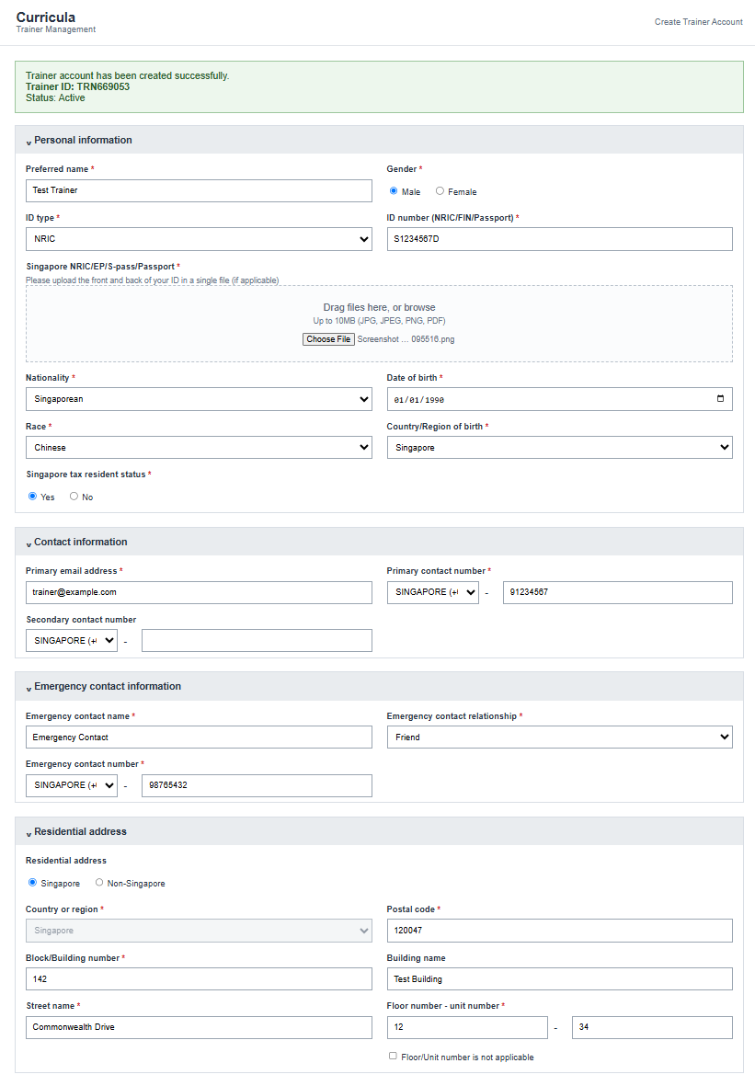
Figure 2. BUG-02 evidence
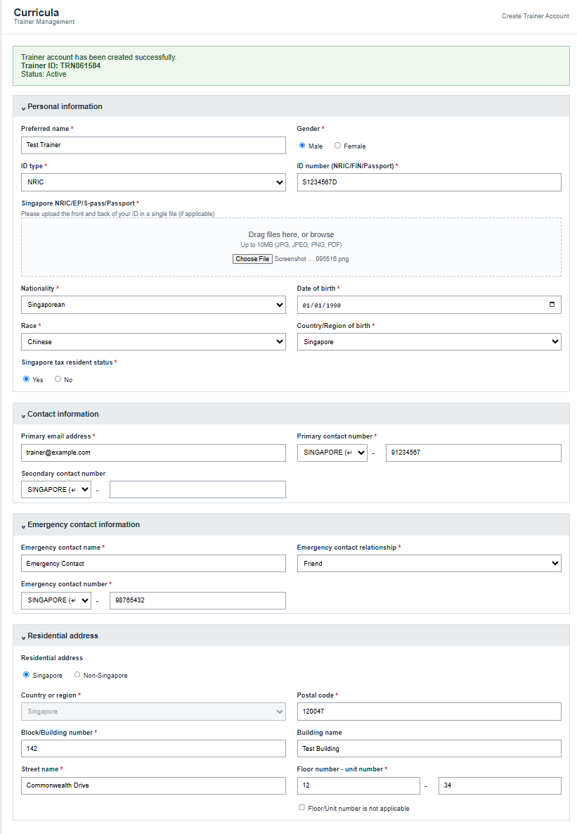Figure 3. BUG-02 evidence

6. BUG-03: Identification Document upload is always mandatory, contradicting its own on-screen hint
Severity: Major Priority: High
Related test case(s): TC-TS01-UPL-001 to 006, TC-TS08-F24-001 to 003
Related requirement finding: F23
Steps to reproduce: 1. Open Create Trainer. 2. Select any ID Type. 3. Leave Identification Document empty. 4. Fill every other mandatory field with valid data. 5. Click Save.
Expected result: Since the field's own hint text reads “Please upload the front and back of your ID in a single file (if applicable)”, at least one scenario should allow Save without a document.
Actual result: Save is blocked in every case; the validation logic requires a file unconditionally, with no exception path tied to ID Type or any other condition.
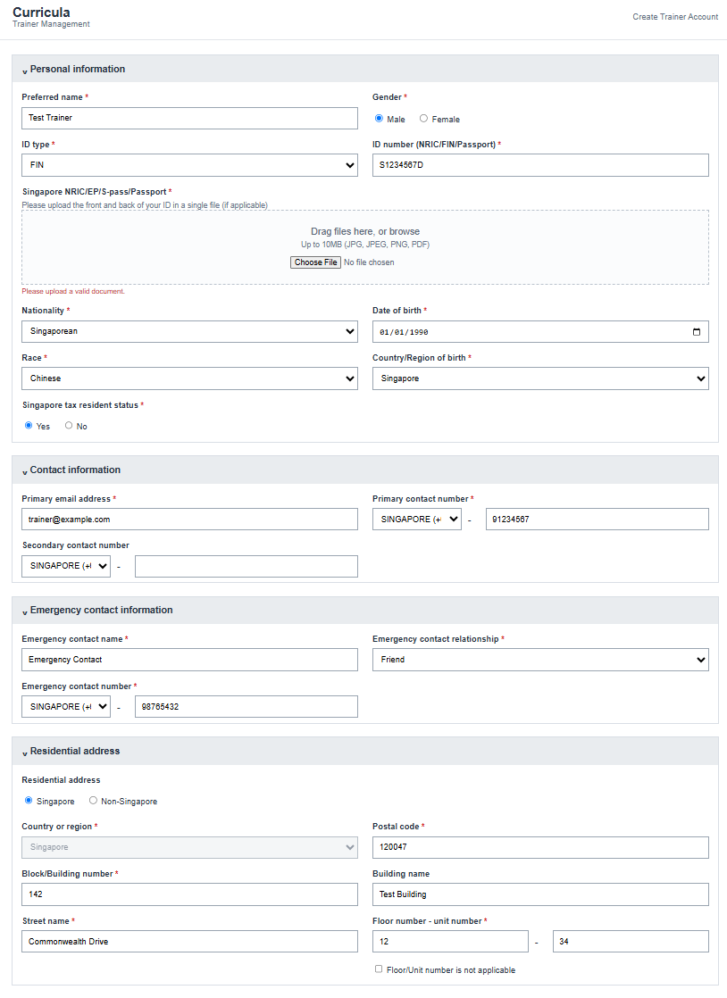
Figure 4. BUG-03 evidence

7. BUG-04: Trainer ID is generated randomly, not sequentially, and is not checked for uniqueness
Severity: Major Priority: Medium
Related test case(s): TC-TS06-SAVE-002 -- Expected Result updated in Step 6 revision 2 to require the FSD Section 7 sequential-number behaviour; the case is now recorded as Failed against this defect.
Related requirement finding: F24
Steps to reproduce: 1. Create and save a trainer account, note the generated Trainer ID. 2. Create and save a second trainer account, note its Trainer ID. 3. Compare the two IDs.
Expected result: Trainer ID increases sequentially, per FSD Section 7's stated format.
Actual result: Trainer ID is generated as 'TRN' + a random 6-digit number (Math.random()), with no sequence and no check against previously issued IDs, so a duplicate Trainer ID is possible without any concurrent save.
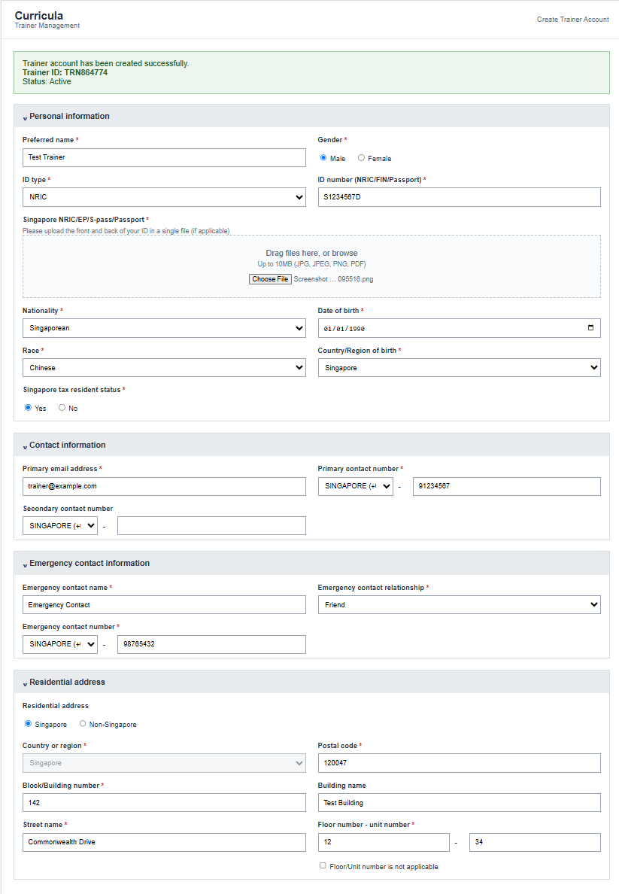Figure 5. BUG-04 evidence
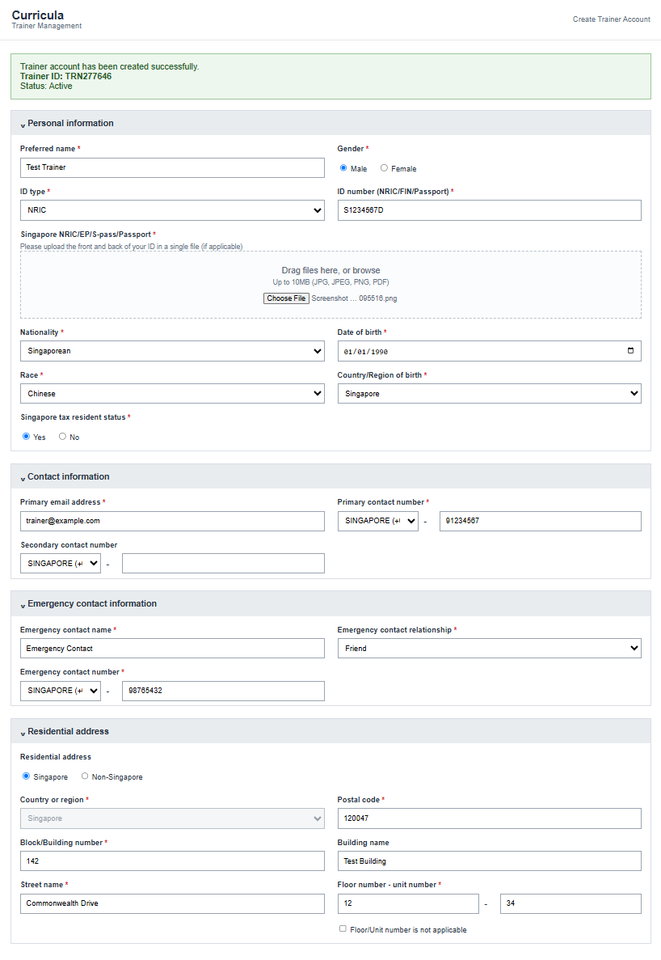Figure 6. BUG-04 evidence

8. BUG-05: ID Type dropdown does not match the FSD's documented enumeration
Severity: Minor Priority: Medium
Related test case(s): TC-TS01-IDT-001 to 004 (NRIC / FIN / Employment Pass / Passport scenarios). Note: the current suite’s TS-08 case labelled "F19" covers Gender, not ID Type -- the finding numbering should be reconciled against the Step 2 source before this report is finalised.
Related requirement finding: F19
Steps to reproduce: 1. Open Create Trainer. 2. Open the ID Type dropdown.
Expected result: Enumeration matches FSD Section 4.1's field table: NRIC / FIN / Employment Pass / Passport (4 values).
Actual result: Dropdown shows 5 values: NRIC / FIN / EP / S-Pass / Passport. Employment Pass and S-Pass are represented as two separate options rather than the FSD's single combined structure.
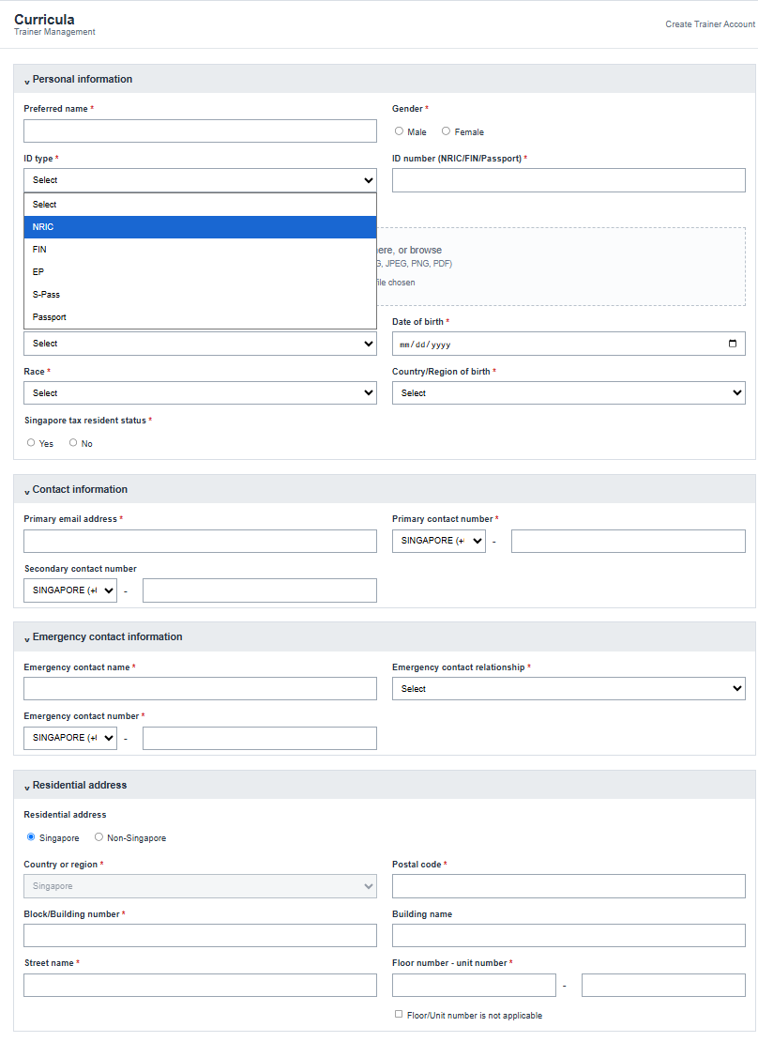Figure 7. BUG-05 evidence

9. BUG-06: Emergency contact relationship dropdown does not match the FSD's documented enumeration
Severity: Minor Priority: Low
Related test case(s): TC-TS03-REL-001 (Parent -- Failed in Step 6) and TC-TS09-F25-001 to 004
Related requirement finding: F25
Steps to reproduce: 1. Open Create Trainer. 2. Open the Emergency contact relationship dropdown.
Expected result: Enumeration matches FSD Section 4.3: Parent / Spouse / Sibling / Relative / Friend / Others (6 values).
Actual result: Dropdown shows 7 values: Father / Mother / Spouse / Sibling / Relative / Friend / Others. Parent is represented as two separate options (Father, Mother) rather than the FSD's single combined value.
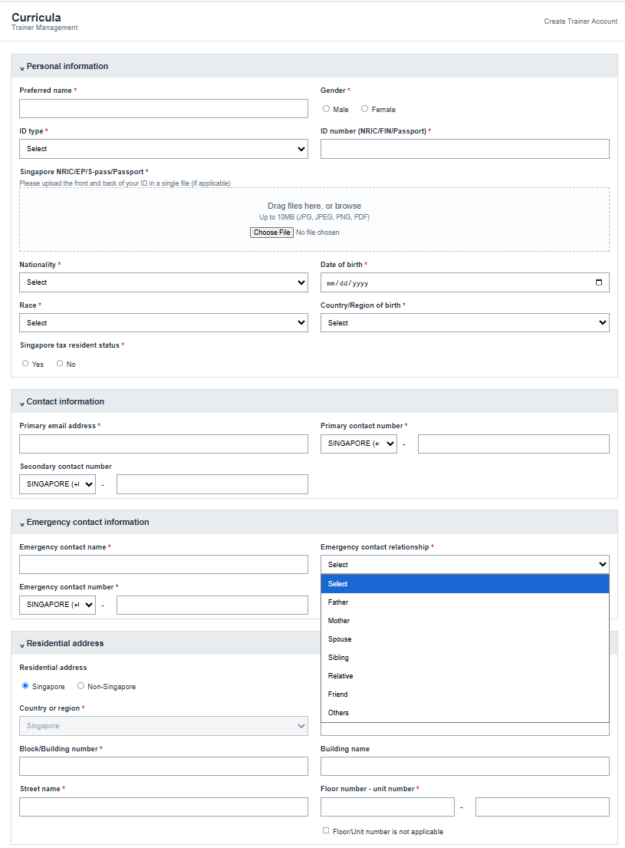Figure 8. BUG-06 evidence

10. BUG-07: Block/Building Number and Unit Number are capped at 9 characters, one short of the FSD's stated 10
Severity: Minor Priority: Medium
Related test case(s): TC-TS04-BLOCK-002/003, TC-TS04-UNIT-002, TC-TS09-F26-001 to 003
Related requirement finding: F26
Steps to reproduce: 1. Open Create Trainer, select Singapore residential address. 2. Enter a 10-character value in Block/Building Number (e.g. "1234567890"). 3. Enter a 10-digit value in Unit Number (e.g. "1234567890").
Expected result: Both values are accepted, per FSD Section 4.4.1 (Block/Building Number and Unit Number both String/10).
Actual result: Both inputs are capped at 9 characters: maxlength="9" on both fields, and Unit Number's save-time regex additionally enforces /^\d{1,9}$/, one character short of the FSD's stated limit.
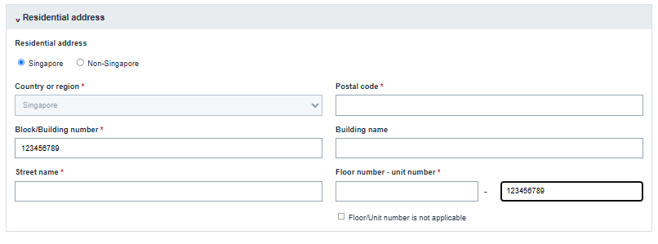
Figure 9. BUG-07 evidence

11. BUG-08: Primary contact number under +65 rejects valid 8-15 digit values outside an undocumented exactly-8 rule
Severity: Major Priority: Medium
Related test case(s): TC-TS02-PPHONE-006, TC-TS03-PHONE-006, TC-TS09-F27-003 (Expected Result corrected in Step 6 revision 2 to the FSD's 8-15 digit rule; all three are now recorded as Failed against this defect). TC-TS02-PPHONE-004/005 and TC-TS03-PHONE-004/005 (7 and 8 digit boundaries) remain Passed, since those values are rejected/accepted consistently with both the build and the FSD.
Related requirement finding: F27
Steps to reproduce: 1. Open Create Trainer. 2. Select Primary contact country code = +65 (Singapore). 3. Enter a 10-digit Primary contact number. 4. Fill every other mandatory field with valid data. 5. Click Save.
Expected result: Save proceeds, per Section 6's general rule that phone number fields are Numeric / 8-15 with no stated per-country-code exception.
Actual result: Save is blocked with "Enter a valid contact number.": the real build enforces exactly 8 digits when the country code is +65, a rule not stated anywhere in the FSD (if (code === '+65') ok = ok && value.length === 8).
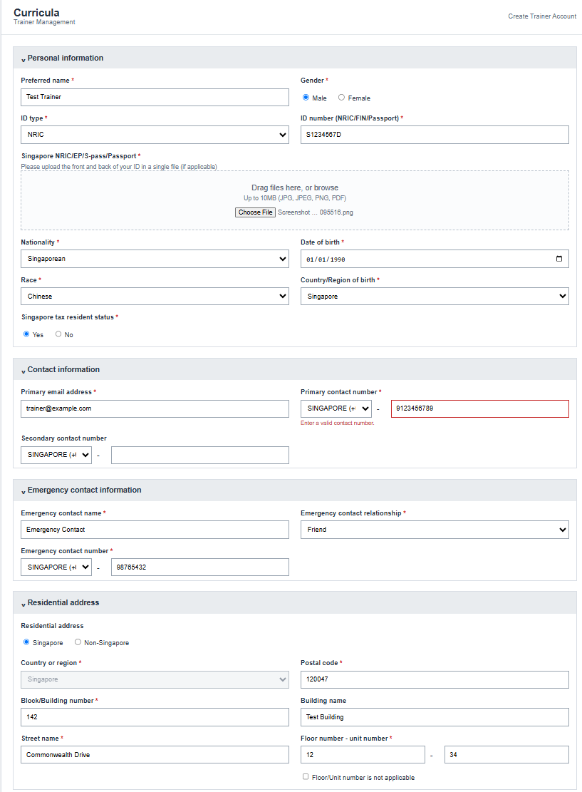Figure 10. BUG-08 evidence

12. BUG-09: Floor Number rejects letter-containing values not restricted by the FSD
Severity: Major Priority: Medium
Related test case(s): TC-TS04-FLOOR-004, TC-TS09-F28-004/005/006
Related requirement finding: F28
Steps to reproduce: 1. Open Create Trainer, select Singapore residential address. 2. Enter Floor Number = "B1", Unit Number = "01". 3. Fill every other mandatory field with valid data. 4. Click Save.
Expected result: Save proceeds, since FSD Section 4.4.1 states Floor Number as String/5 with no character-type restriction.
Actual result: Save is blocked with "Floor and unit number are required.": the real build enforces a digits-only regex (/^\d{1,5}$/) on Floor Number, rejecting letter-containing labels common in Singapore addresses (B1, G, LG, MEZZ).
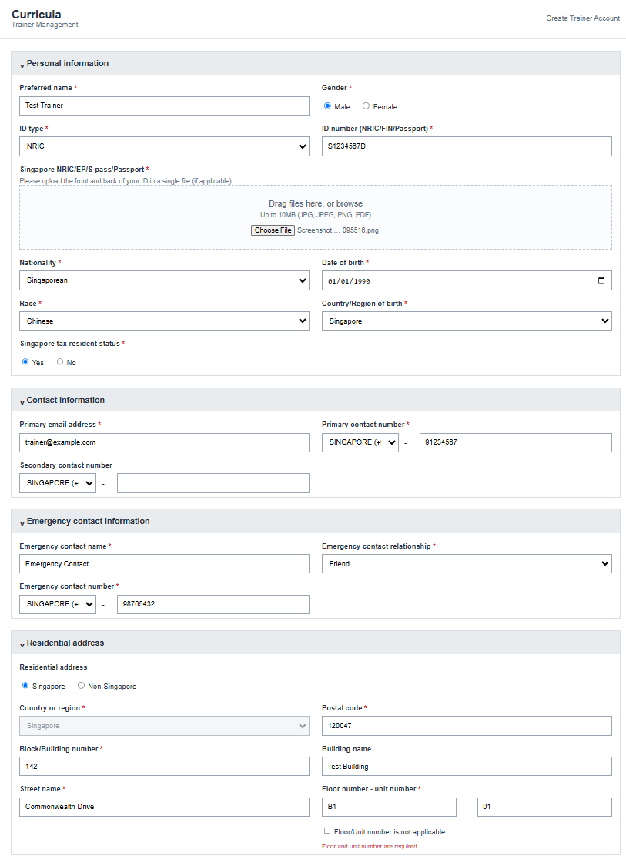Figure 11. BUG-09 evidence

13. BUG-10: Preferred Name and Emergency Contact Name accept up to 255 characters instead of the FSD’s stated 100
Severity: Medium Priority: Medium
Related test case(s): TC-TS01-PI-004/005, TC-TS03-NAME-004/005
Related requirement finding: None (identified during Test Execution, Step 6)
Steps to reproduce: 1. Open Create Trainer. 2. Enter a Preferred Name (or Emergency Contact Name) of 101 characters. 3. Fill every other mandatory field with valid data. 4. Click Save.
Expected result: Save is blocked, or the value is truncated to 100 characters, per FSD Section 4.1/4.3 (Preferred Name and Emergency Contact Name are both String/100).
Actual result: Save succeeds with the full 101-character value retained. Both fields have HTML maxlength="255" and no JavaScript length check, so any value up to 255 characters is accepted.
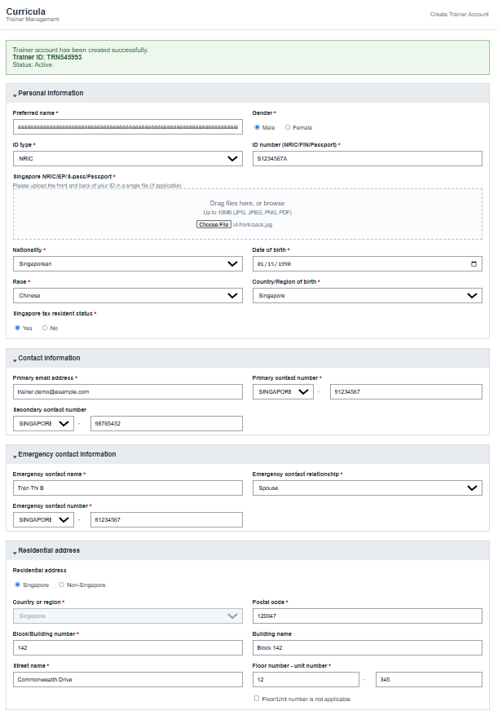
Figure 12. BUG-10 evidence

14. BUG-11: Country/Region dropdown still allows Singapore to be selected in Non-Singapore mode
Severity: Low Priority: Low
Related test case(s): TC-TS05-NSG-003
Related requirement finding: None (identified during Test Execution, Step 6)
Steps to reproduce: 1. Open Create Trainer. 2. Select Non-Singapore residential address. 3. Open the Country/Region dropdown. 4. Select "Singapore".
Expected result: Singapore is unavailable for selection, per FSD Section 4.4.2: "Country/Region must not allow Singapore when Non-Singapore is selected."
Actual result: The "Singapore" option remains present and enabled in the dropdown and can be selected; it is only rejected later, at Save time (countryOk check), rather than being removed or disabled in the dropdown itself.
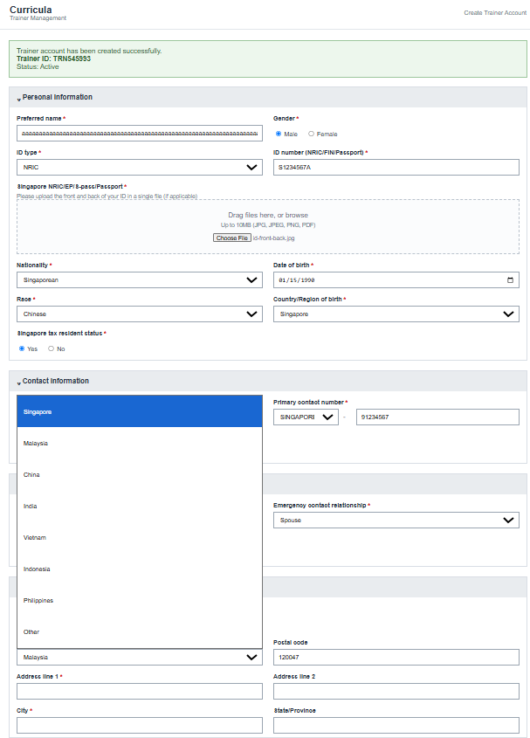
Figure 13. BUG-11 evidence
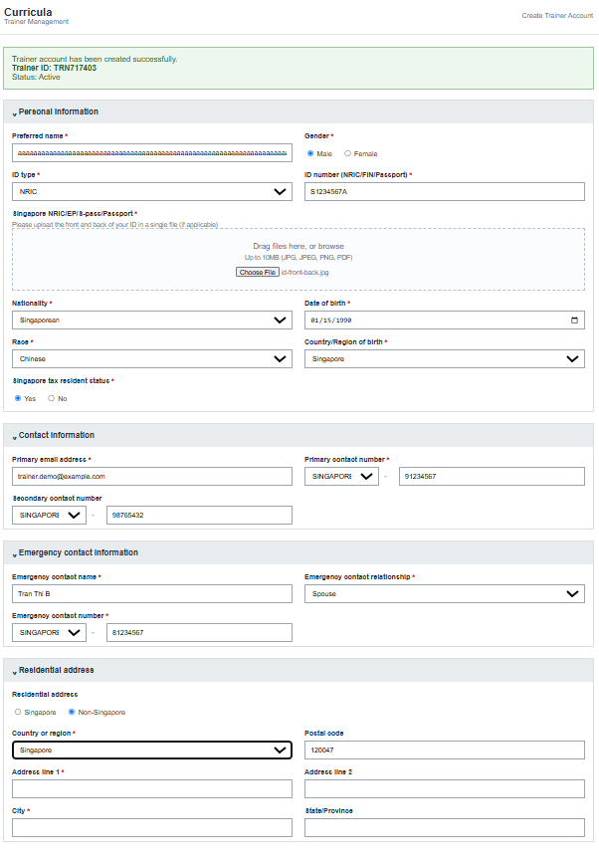
Figure 14. BUG-11 evidence
15. BUG-12: Non-Singapore Postal Code has no length restriction
Severity: Low Priority: Low
Related test case(s): TC-TS05-PC-003/004
Related requirement finding: None (identified during Test Execution, Step 6)
Steps to reproduce: 1. Open Create Trainer. 2. Select Non-Singapore residential address. 3. Enter a Postal Code value of 21 characters. 4. Click Save.
Expected result: Value is restricted to 20 characters, per FSD Section 4.4.2 (Non-Singapore Postal Code is String/20).
Actual result: The value is accepted in full. The field has no JavaScript length or format check in Non-Singapore mode (showError is always cleared for this field outside Singapore mode), and HTML maxlength="255" is far above the FSD’s 20-character limit.
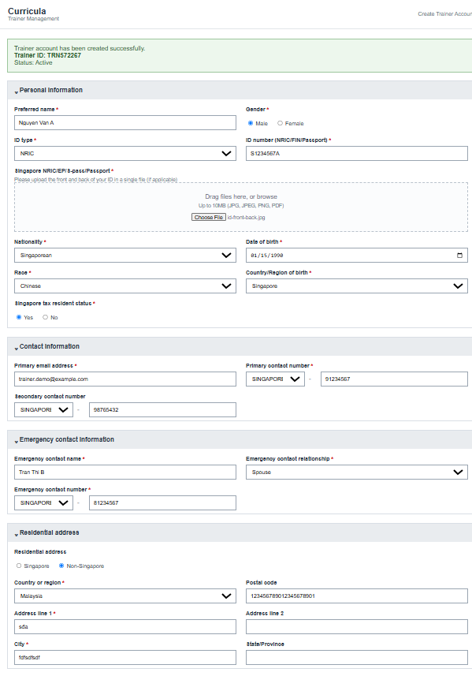
Figure 15. BUG-12 evidence

References
[1] Understand Scope report (Step 1), Curricula: Trainer Account Creation QA workflow.
[2] Requirement Analysis Findings report (Step 2), Curricula: Trainer Account Creation QA workflow.
[3] Test Plan (Step 3), Curricula: Trainer Account Creation QA workflow.
[4] Curricula, Trainer Account Creation, Functional Specification Document, version 1.0.
[5] curricula_trainer_account.html, the real build for this release (single static HTML file).

